PRACTICAL WEEK-3

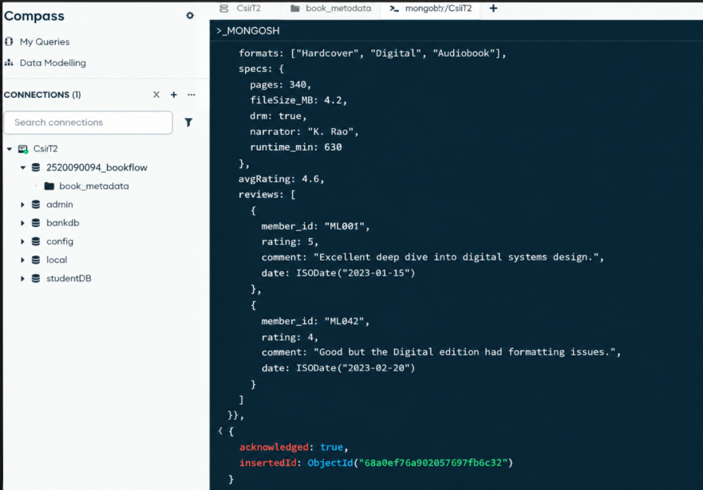
Task - 1. Document Modelling

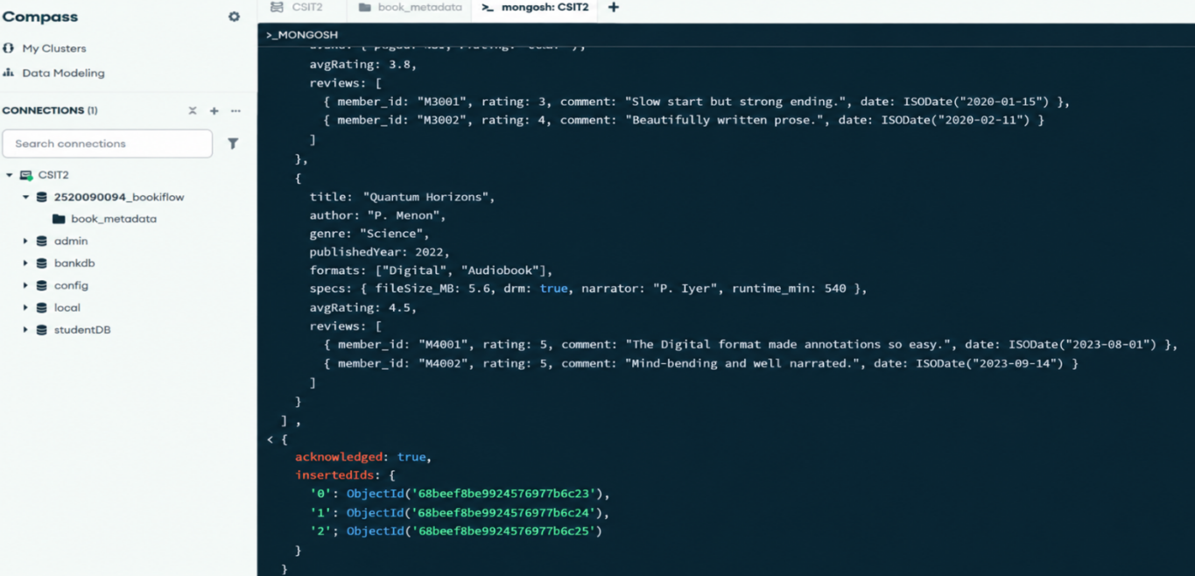

Task 2.• Advancing query
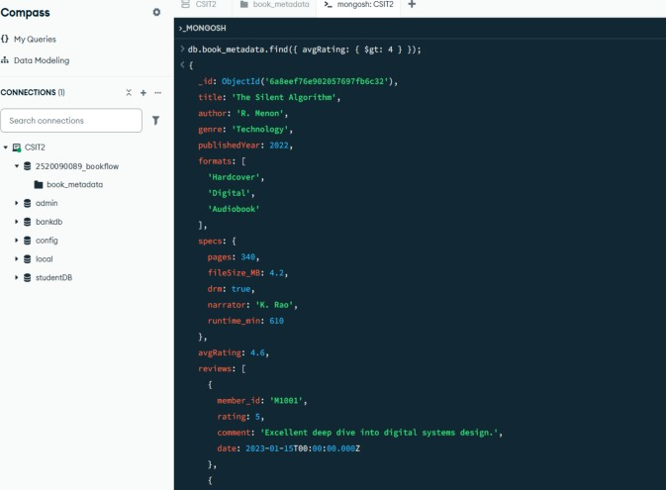
1.Books rated above 4 (Sgt)
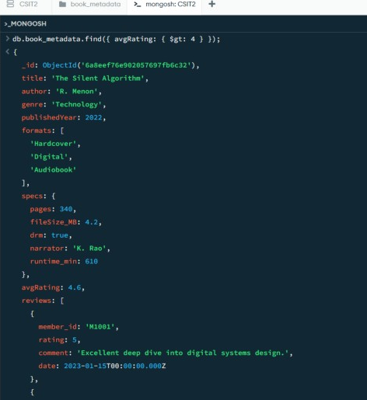
- Books available in specific formats (Sin)
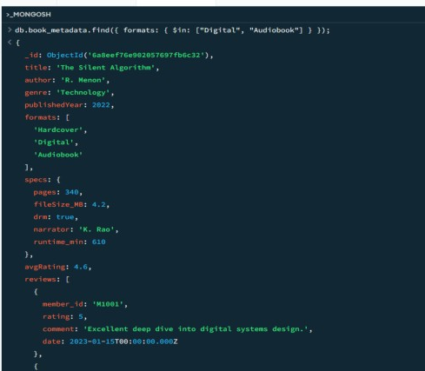
- Combine both with Sand (implicit)
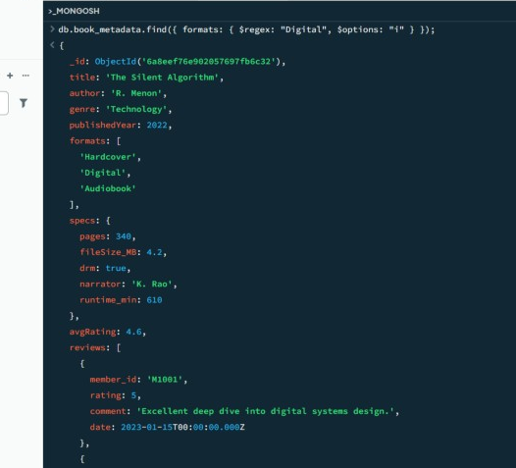
- Regex query — books with "Digital" format
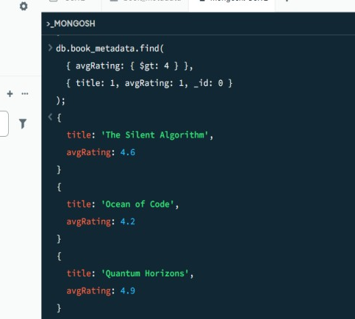•
- Regex query — reviews mentioning "Digital" in comments (nested field)
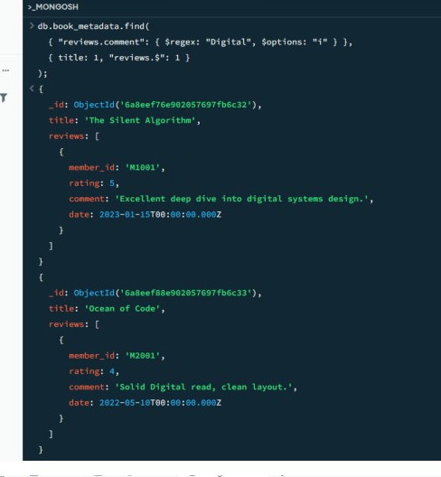
Task 3: Aggregation Pipeline — "Top Rated" Report
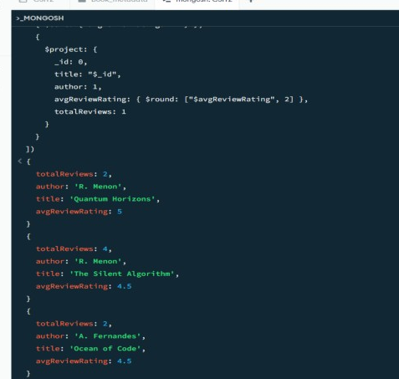
Task 4 : Indexing for Speed
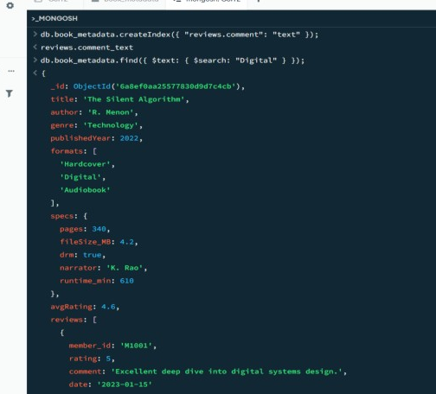
b) Query using the text index
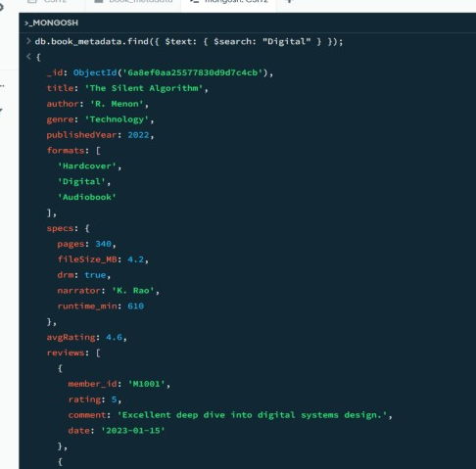
C) Verify index usage with .explain()
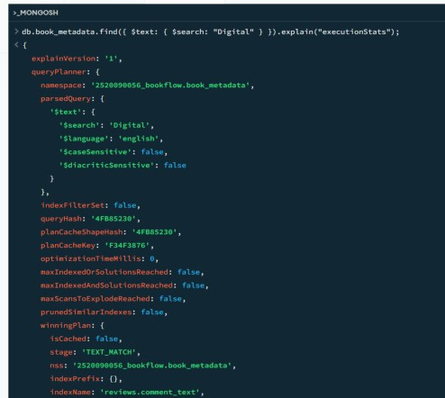
- Compare against a non-indexed regex scan
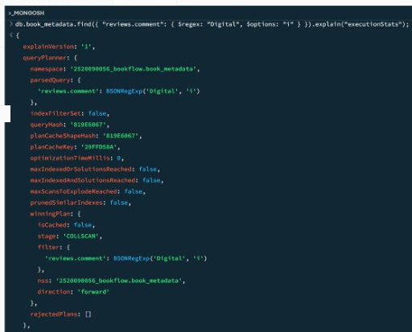
- Supporting index for common queries (multikey index)
